What is a Framework?
A framework is a particular set of rules, ideas, or beliefs which you use in order to deal with problems or to decide what to do.
What is Django?
Django is a high-level Python web framework that helps you build web applications quickly and safely.
- Django is an open-source python framework. You can simply install it through pip install django command.
- Django follows the model-view-template architectural pattern.
- It gives you ORM (Object Relational Mapping – allows you to interact with a database {like SQLite, MySQL, or PostgreSQL} using Python objects -instead of writing raw SQL queries.), routing, templates (HTML), admin panel, forms, security features, and more out of the box.
Prerequisite – HTML, CSS, JavaScript, Database Management, Basic knowledge of Python.
MVT architecture
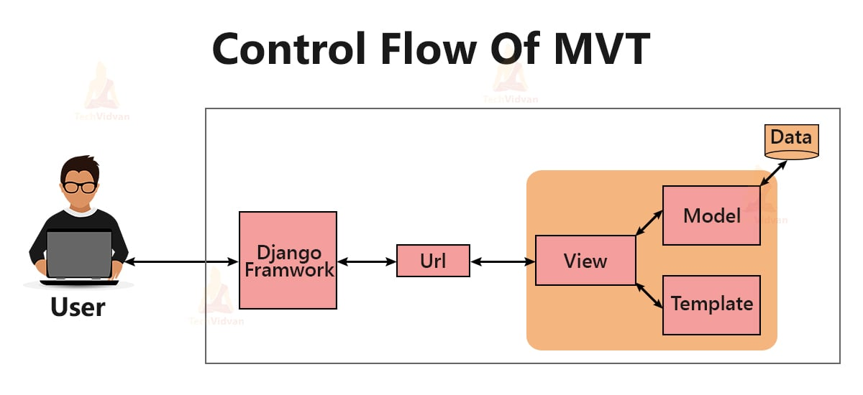
- Model – The Data Layer:

Defines the structure of your database tables. This is a class-based model where each model maps to a table, and each attribute maps to a column and instance of the class represents the rows of the table. Main functionality to handle data validation, database queries (creation, retrieval, update, deletion), and relationships between different data entities.
- Templates
Templates are typically HTML files that contain static content and also embed dynamic content taking from model also control the flow of presentation. It is known as presentation layer.
- View
Handles the application’s logic and functionality. It receives user requests, interacts with the Model to fetch or modify data, and prepares the data to be displayed.
Installation Process of Django (very simple)
Commands (run in terminal) (Assuming everyone already has Python installed. If not, please kindly install the latest version.)
Create virtual environment to a specific folder. From that specific folder open cmd and execute following command.
python -m venv venv

Then you will see like as fellow:
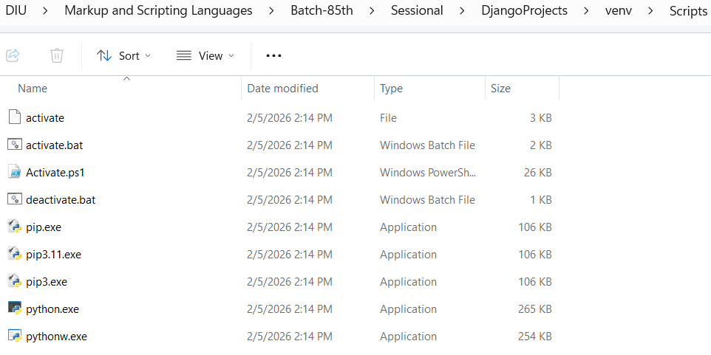
For activating virtual environment write following command
venv\Scripts\activate
For installing Django write following command:
pip install django

It will take some time.
Then check version
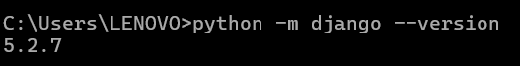
Now we will start our Django project inside a dedicated folder where we will keep all our Django projects. Open command prompt as follow: 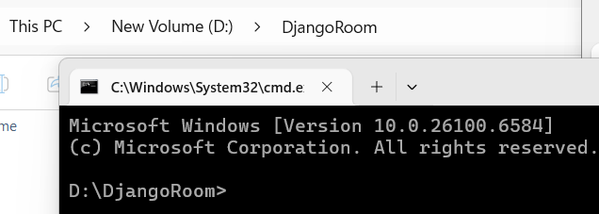
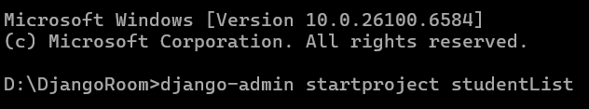
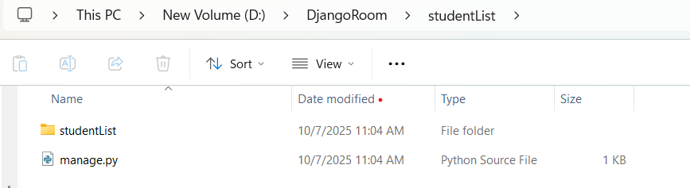
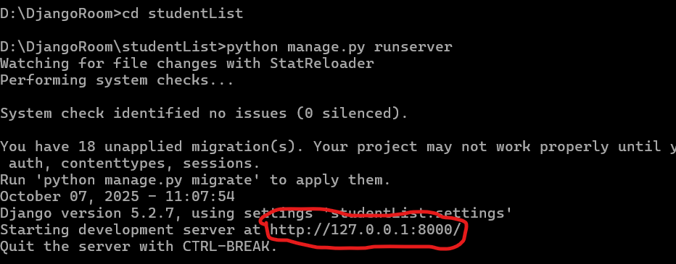
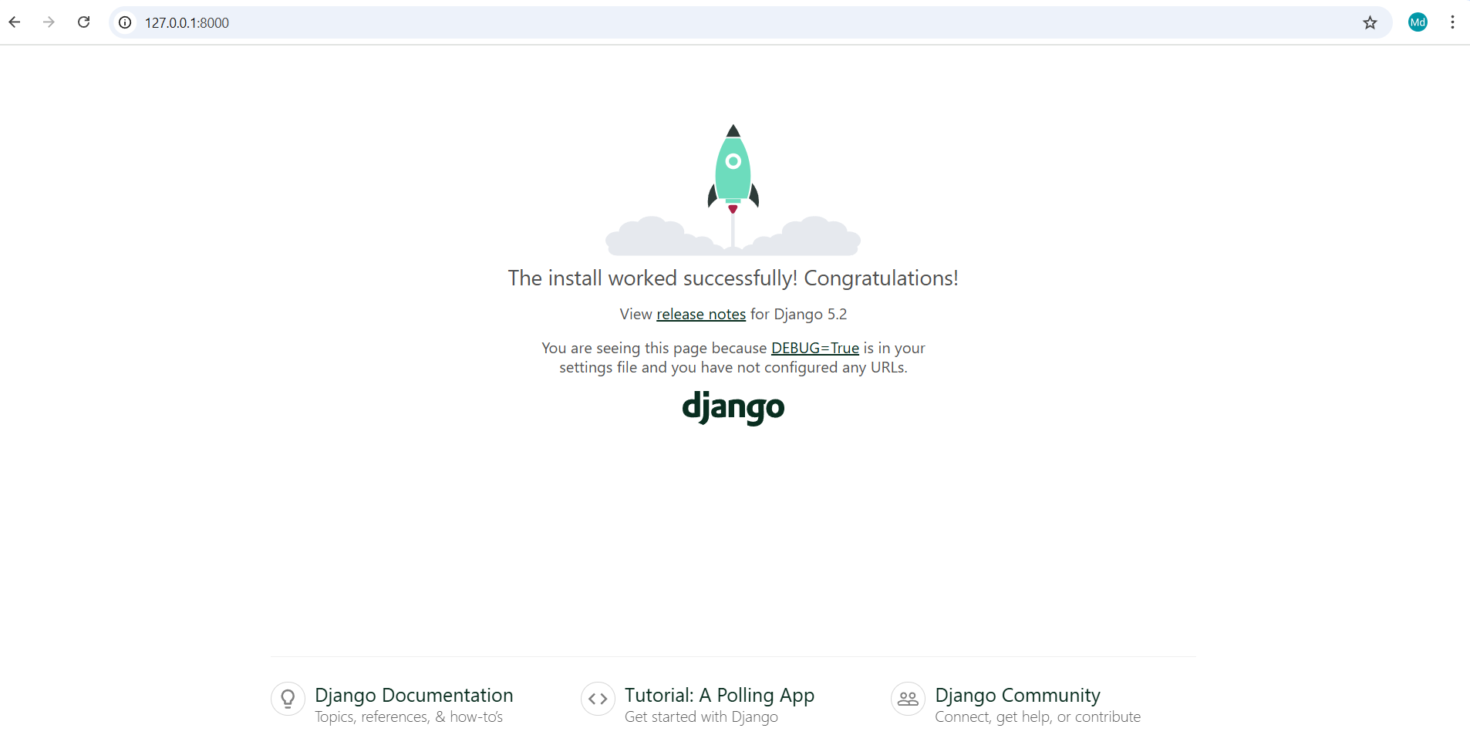
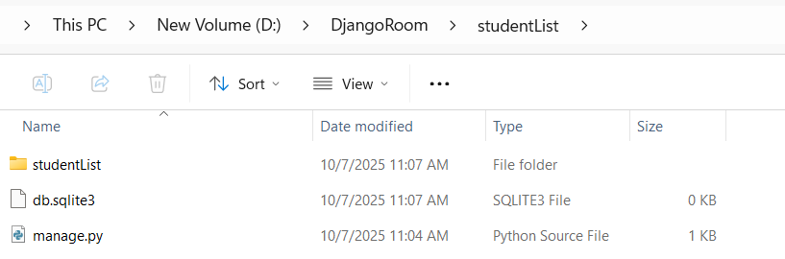
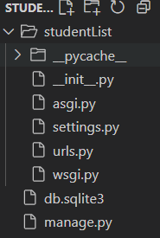
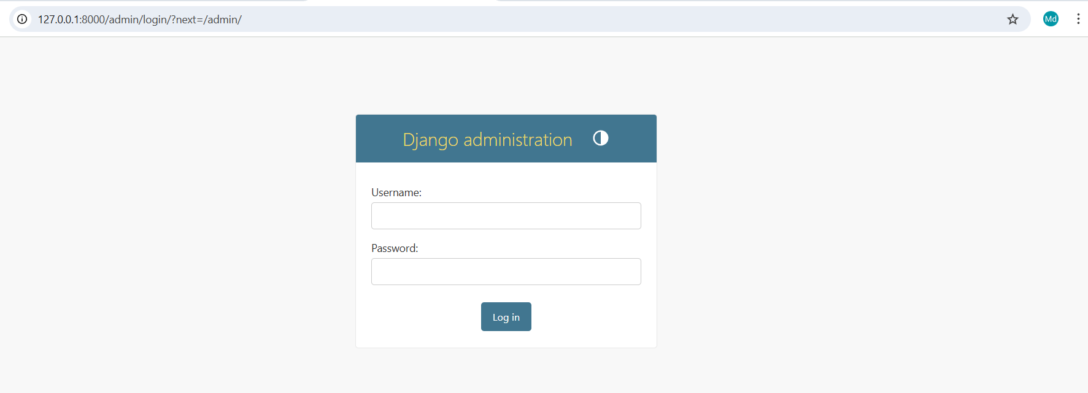
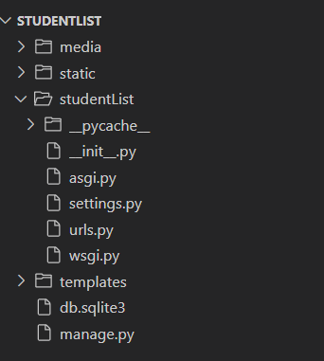
What is manage.py?
It is a command-line utility known as manager of your project by interacting with your Django project in various ways- like running the server, creating apps, migrating databases, managing users etc.
What is settings.py?
Contains all the configuration settings known as a control center of your Django project.

What is settings.py?
This file tells Django how your project should work — like a control center.
It stores:
- Secret keys.
- Database connection.
- Installed apps.
- Time zone.
- Where HTML, CSS, JS files are stored.
- Import and Base Directory
from pathlib import Path

# Build paths inside the project like this: BASE_DIR / 'subdir'.
BASE_DIR = Path(__file__).resolve().parent.parent

- from pathlib import Path→ helps Django find folders easily.
- BASE_DIR → main folder of your project.
Example: if your project folder is mysite/, this line helps Django know where to find files like templates, static, etc.
- Security and Debug
# SECURITY WARNING: keep the secret key used in production secret!
SECRET_KEY = 'django-insecure-2&qc!&#jij!(p)oxmrf=*$40$k9@-q%&vc3m08v1!n!%pta^n#'

# SECURITY WARNING: don't run with debug turned on in production!
DEBUG = True

ALLOWED_HOSTS = []

- SECRET_KEY: A secret code used by Django to protect your website. Keep it safe.
- DEBUG = True: Means Django will show detailed error messages — good for development.
In real websites (production), you’ll set DEBUG = False.
- ALLOWED_HOSTS: When you make your site live, you’ll list your website name here.
Example: ALLOWED_HOSTS = ['127.0.0.1', 'mycakeshop.com']
- ALLOWED_HOSTS = []

- Installed Apps
# Application definition

INSTALLED_APPS = [
'django.contrib.admin',
'django.contrib.auth',
'django.contrib.contenttypes',
'django.contrib.sessions',
'django.contrib.messages',
'django.contrib.staticfiles',

Think of this like a list of “features” Django will use.
- admin → admin dashboard
- auth → login/logout system
- sessions → store user sessions (login info)
- messages → system for success/error messages
- staticfiles → handle CSS, JS, and images
- Middleware
MIDDLEWARE = [
'django.middleware.security.SecurityMiddleware',
'django.contrib.sessions.middleware.SessionMiddleware',
'django.middleware.common.CommonMiddleware',
'django.middleware.csrf.CsrfViewMiddleware',
'django.contrib.auth.middleware.AuthenticationMiddleware',
'django.contrib.messages.middleware.MessageMiddleware',
'django.middleware.clickjacking.XFrameOptionsMiddleware',
]

Middleware = “Middle helpers” between the user and your website.
They:
- Protect your site from attacks (like CSRF)
- Manage user logins
- Handle cookies and messages
You usually don’t change this part.

- Root URL and WSGI
ROOT_URLCONF = 'mysite.urls'
WSGI_APPLICATION = 'mysite.wsgi.application'

- ROOT_URLCONF: Tells Django where your urls.py file is (it controls the links).
- WSGI_APPLICATION: Needed for server deployment — you can ignore it for now.
- Templates
TEMPLATES = [
{
'BACKEND': 'django.template.backends.django.DjangoTemplates',
'DIRS': [],
'APP_DIRS': True,
'OPTIONS': {
'context_processors': [
'django.template.context_processors.request',
'django.contrib.auth.context_processors.auth',
'django.contrib.messages.context_processors.messages',
],
},
},
]

This section tells Django where to find your HTML files.
'DIRS': [] → You can tell Django where your template folder is.
TEMPLATES = [
{
'BACKEND': 'django.template.backends.django.DjangoTemplates',
'DIRS': [BASE_DIR / 'templates'],
'APP_DIRS': True,
'OPTIONS': {
'context_processors': [
'django.template.context_processors.request',
'django.contrib.auth.context_processors.auth',
'django.contrib.messages.context_processors.messages',
],
},},
]

Django will look inside each app’s templates folder automatically.
- Database
DATABASES = {
'default': {
'ENGINE': 'django.db.backends.sqlite3',
'NAME': BASE_DIR / 'db.sqlite3',
}
}

Right now it uses SQLite, a small database file — perfect for beginners. Later we’ll change it to MySQL using XAMPP. For now, keep this as it is.
Example MySQL (we’ll do this together later):
DATABASES = {
'default': {
'ENGINE': 'django.db.backends.mysql',
'NAME': 'cake_shop_db',
'USER': 'root',
'PASSWORD': '',
'HOST': '127.0.0.1',
'PORT': '3306',
}
}

- Password Validation

AUTH_PASSWORD_VALIDATORS = [
{
'NAME': 'django.contrib.auth.password_validation.UserAttributeSimilarityValidator',
},
{
'NAME': 'django.contrib.auth.password_validation.MinimumLengthValidator',
},
{
'NAME': 'django.contrib.auth.password_validation.CommonPasswordValidator',
},
{
'NAME': 'django.contrib.auth.password_validation.NumericPasswordValidator',
},
]

These rules make sure users choose strong passwords (not too short or too simple).
- Language and Timezone
LANGUAGE_CODE = 'en-us'

TIME_ZONE = 'Asia/Dhaka'

USE_I18N = True

USE_TZ = True

- Static Files (CSS, JS, Images)
STATIC_URL = [BASE_DIR / 'static']
Or
STATIC_URL = 'static/'
STATICFILES_DIRS = [BASE_DIR / 'static']

This tells Django that when you use {% static 'css/style.css' %} in HTML,
it should look in the static folder.
- Default Auto Field
DEFAULT_AUTO_FIELD = 'django.db.models.BigAutoField'

This sets how Django creates ID numbers for your database tables.
Leave it as it is.
- How to Migrate Default Migrations
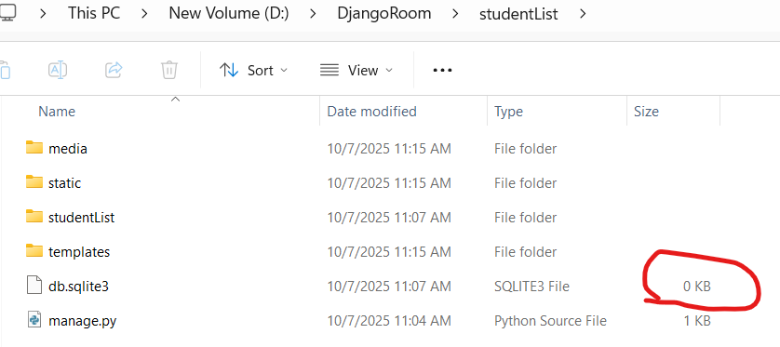
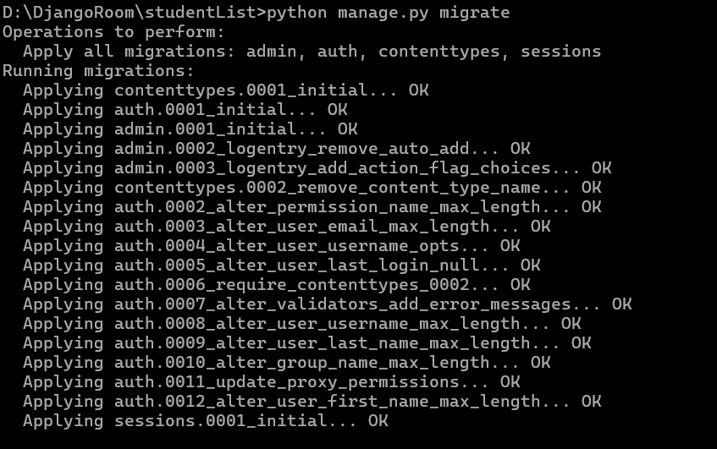
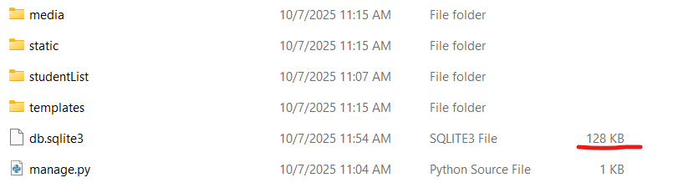
Install DB Browser for viewing SQLite3 tables. Install from following link.
https://sqlitebrowser.org/dl/
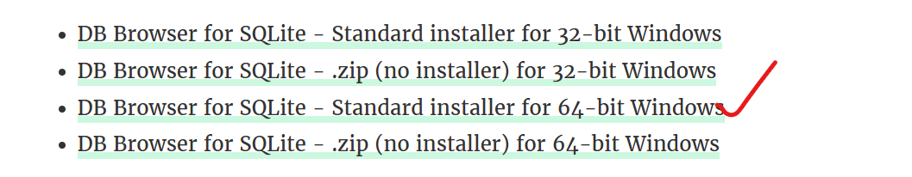
Then Open DB Browser and click on Open Database then select db.sqlite3 from your project folder.
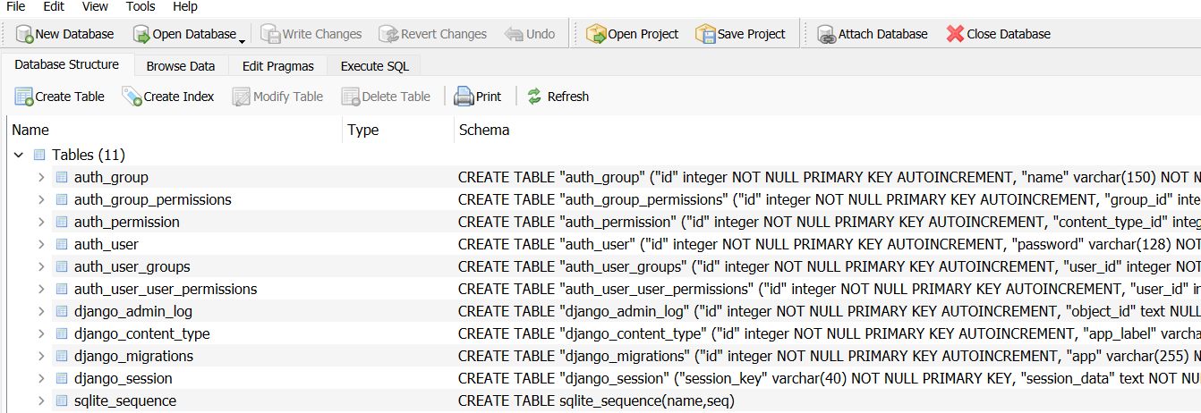
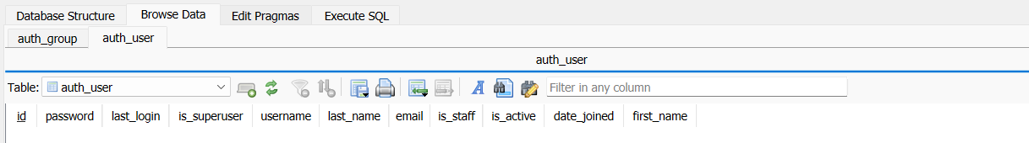
Now we will create super user to manage the admin panel.
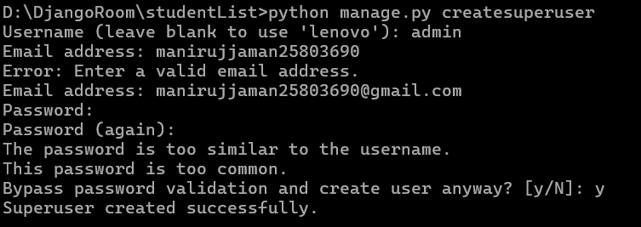
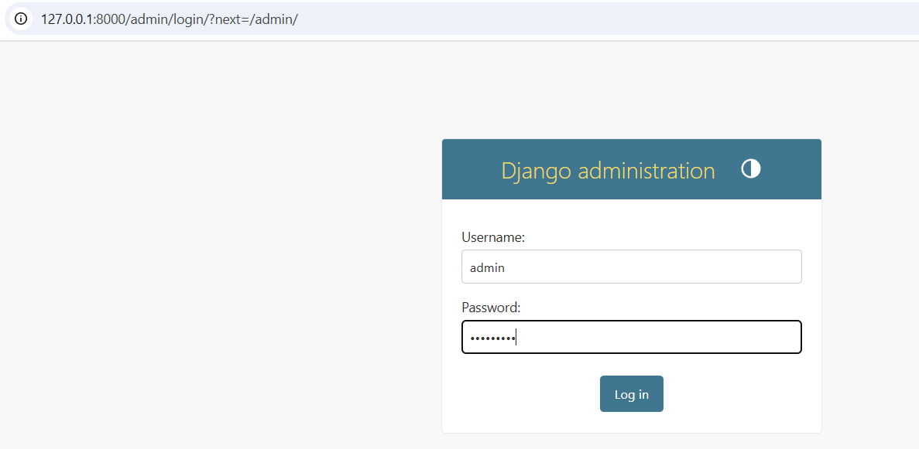
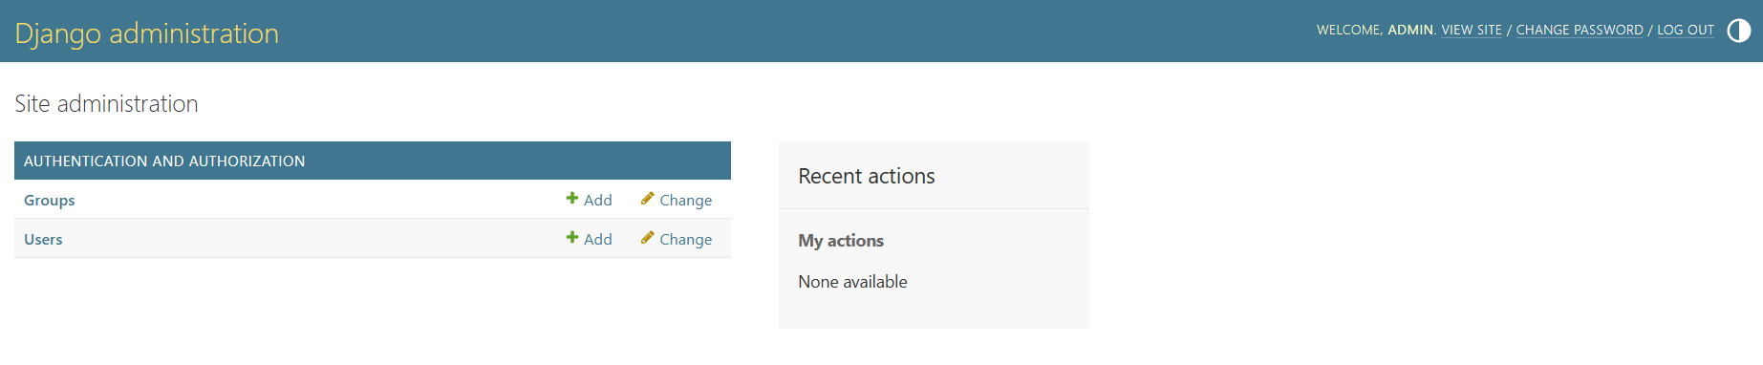
Let's dive into rendering! First, we'll render an HTML page along with its associated CSS and JavaScript static files. After that, we'll connect the page to a SQLite3 database within our Django project. For demonstration, we'll build a simple project called Student Information, where the page will display student details fetched directly from the database.

Set your project folder as follows:
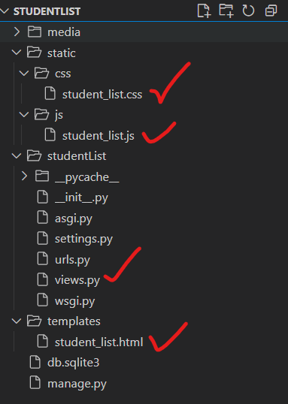

HTML File: student_list.html
<!DOCTYPE html>
<html lang="en">
<head>
<meta charset="UTF-8">
<meta name="viewport" content="width=device-width, initial-scale=1.0">
<title>Student List</title>
{% load static %}
<link rel="stylesheet" href="{% static 'css/student_list.css' %}">
</head>
<body>
<div class="container">
<h1>Student Information System</h1>
<table id="studentTable">
<thead>
<tr>
<th>Student ID</th>
<th>Name</th>
<th>Department</th>
<th>Phone No</th>
<th>Address</th>
</tr>
</thead>
<tbody>
<!-- Dummy data (will be replaced by DB data later) -->
<tr>
<td>STU001</td>
<td>Rakib Hasan</td>
<td>CSE</td>
<td>01711111111</td>
<td>Rajshahi</td>
</tr>
<tr>
<td>STU002</td>
<td>Nusrat Jahan</td>
<td>EEE</td>
<td>01822222222</td>
<td>Dhaka</td>
</tr>
<tr>
<td>STU003</td>
<td>Sabbir Hossain</td>
<td>BBA</td>
<td>01933333333</td>
<td>Rangpur</td>
</tr>
</tbody>
</table>
</div>

<script src="{% static 'js/student_list.js' %}"></script>
</body>
</html>

CSS: student_list.css
:root {
--bg: #f4f7fb;
--card: #ffffff;
--text: #0f172a;
--muted: #64748b;
--border: rgba(15, 23, 42, 0.10);
--shadow: 0 10px 30px rgba(15, 23, 42, 0.10);
--shadow-soft: 0 6px 18px rgba(15, 23, 42, 0.08);
--primary: #2563eb;
--primary-dark: #1d4ed8;
--primary-soft: rgba(37, 99, 235, 0.12);
--radius: 16px;
}

/* Page base */
* {
box-sizing: border-box;
}

body {
font-family: ui-sans-serif, system-ui, -apple-system, "Segoe UI", Roboto, Arial, "Noto Sans", "Helvetica Neue", sans-serif;
background:
radial-gradient(1000px 500px at 20% 0%, rgba(37, 99, 235, 0.10), transparent 60%),
radial-gradient(900px 480px at 90% 10%, rgba(99, 102, 241, 0.10), transparent 55%),
var(--bg);
margin: 0;
padding: 0;
color: var(--text);
}

/* Container card */
.container {
width: min(1100px, 92%);
margin: 48px auto;
background: var(--card);
padding: 28px 28px;
border-radius: var(--radius);
box-shadow: var(--shadow);
border: 1px solid var(--border);
position: relative;
overflow: hidden;
}

/* Subtle top accent bar (still no HTML changes) */
.container::before {
content: "";
position: absolute;
inset: 0 0 auto 0;
height: 6px;
background: linear-gradient(90deg, var(--primary), rgba(99, 102, 241, 0.95), rgba(37, 99, 235, 0.75));
}

/* Title */
h1 {
margin: 8px 0 22px;
text-align: center;
font-size: clamp(22px, 2.2vw, 30px);
letter-spacing: 0.2px;
color: var(--text);
font-weight: 800;
}

/* Table wrapper behavior (kept same HTML, but table becomes safer on small screens) */
table {
width: 100%;
border-collapse: separate;
border-spacing: 0;
overflow: hidden;
border-radius: 14px;
border: 1px solid var(--border);
background: #fff;
}

/* Header */
thead th {
background: linear-gradient(180deg, var(--primary), var(--primary-dark));
color: #fff;
text-transform: none; /* professional look: no forced uppercase */
font-weight: 700;
font-size: 14px;
letter-spacing: 0.3px;
padding: 14px 12px;
border: none;
}

/* Body cells */
tbody td {
padding: 14px 12px;
text-align: center;
font-size: 14px;
color: var(--text);
border-top: 1px solid var(--border);
}

/* Row styling */
tbody tr {
background: #fff;
transition: transform 0.15s ease, box-shadow 0.15s ease, background 0.15s ease;
}

tbody tr:nth-child(even) {
background: rgba(15, 23, 42, 0.02);
}

/* Hover effect - subtle, premium */
tbody tr:hover {
background: rgba(37, 99, 235, 0.06);
box-shadow: var(--shadow-soft);
transform: translateY(-1px);
}

/* Selected row (your JS class) */
.selected {
background: var(--primary-soft) !important;
outline: 2px solid rgba(37, 99, 235, 0.25);
outline-offset: -2px;
}

/* Softer borders at edges */
thead th:first-child {
border-top-left-radius: 14px;
}
thead th:last-child {
border-top-right-radius: 14px;
}

/* Improve readability for long text (like Address) */
td {
word-break: break-word;
}

/* Responsive improvements */
@media (max-width: 768px) {
.container {
padding: 22px 16px;
margin: 28px auto;
}

h1 {
margin: 8px 0 18px;
}

thead th, tbody td {
padding: 12px 10px;
font-size: 13px;
}

/* Horizontal scroll for narrow screens without HTML changes */
table {
display: block;
overflow-x: auto;
-webkit-overflow-scrolling: touch;
}
}

/* Optional: nicer scrollbar (works in WebKit browsers) */
table::-webkit-scrollbar {
height: 10px;
}
table::-webkit-scrollbar-thumb {
background: rgba(15, 23, 42, 0.20);
border-radius: 999px;
}
table::-webkit-scrollbar-track {
background: rgba(15, 23, 42, 0.06);
border-radius: 999px;
}

JS: student_list.js
document.addEventListener("DOMContentLoaded", () => {
const rows = document.querySelectorAll("#studentTable tbody tr");

rows.forEach(row => {
row.addEventListener("click", () => {
// remove selection from all rows
rows.forEach(r => r.classList.remove("selected"));

// add selection to clicked row
row.classList.add("selected");

// simple feedback (optional)
const studentName = row.cells[1].innerText;
console.log("Selected:", studentName);
});
});
});

Before proceeding with rendering, paste the following code into your views.py file.
from django.http import HttpResponse #for displaying simple text response to my browser

def homePage(request):
return HttpResponse("<h1>This a simple Home page </h1>")

Then set URL in urls.py
from django.contrib import admin
from django.urls import path
from . import views

urlpatterns = [
path('admin/', admin.site.urls),
path('', views.homePage, name='home'), # Map the root URL to the homePage view
]

After running the server you will see following page output
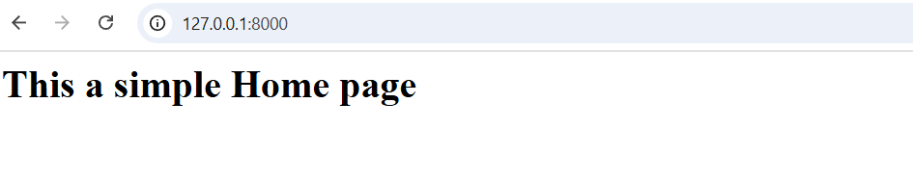
Let’s render the student_list.html page in a new URL through views.
So update your views.py as follows:
from django.http import HttpResponse #for displaying simple text response to my browser
from django.shortcuts import render

def homePage(request):
return HttpResponse("<h1>This a simple Home page </h1>")
def student_list(request):
return render(request, 'student_list.html')

and also update urls.py as follows:
from django.contrib import admin
from django.urls import path
from . import views

urlpatterns = [
path('admin/', admin.site.urls),
path('', views.homePage, name='home'), # Map the root URL to the homePage view
path('student-list/', views.student_list, name='student_list'),
]

You will see the student List page as fellow:
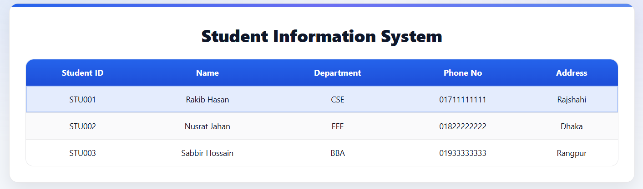
Now for creating table and fetching data from database follow the following command.
Create a Model (in studentList/models.py)
Open models.py and paste following code
from django.db import models

class Student(models.Model):
student_id = models.CharField(max_length=10, unique=True)
name = models.CharField(max_length=100)
department = models.CharField(max_length=50)
phone_no = models.CharField(max_length=15)
address = models.CharField(max_length=100)

def __str__(self):
return self.name

Step 2: Register the App
Open studentlist/settings.py
INSTALLED_APPS = [
'django.contrib.admin',
'django.contrib.auth',
'django.contrib.contenttypes',
'django.contrib.sessions',
'django.contrib.messages',
'django.contrib.staticfiles',
'studentList',
]
Then write given command in terminal cmd
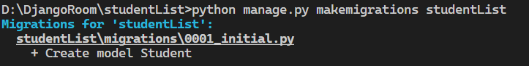
Your project folder will look like as following
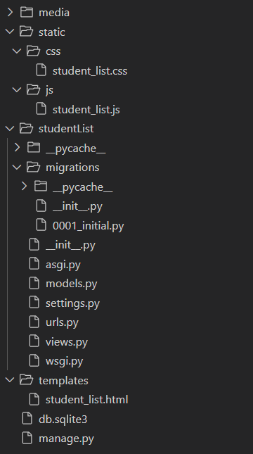
Now write following command:
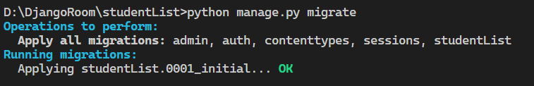
studentList_student table is created in you SQLite3 database.
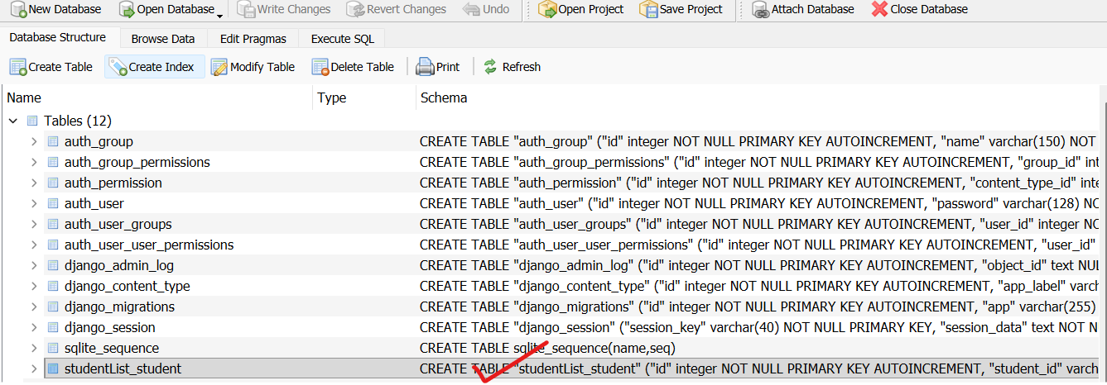
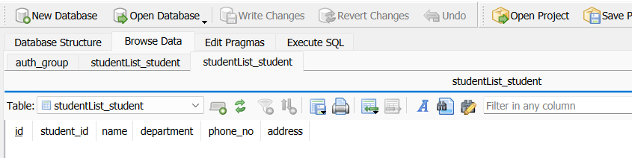

Add Some Data (for testing)
Add following data:
from studentList.models import Student
Student.objects.create(student_id='STU001', name='Rakib Hasan', department='CSE', phone_no='01711111111', address='Rajshahi')
Student.objects.create(student_id='STU002', name='Nusrat Jahan', department='EEE', phone_no='01822222222', address='Dhaka')
Student.objects.create(student_id='STU003', name='Sabbir Hossain', department='BBA', phone_no='01933333333', address='Rangpur')
exit()

Now update views.py
from django.http import HttpResponse #for displaying simple text response to my browser
from django.shortcuts import render
from .models import Student

def homePage(request):
return HttpResponse("<h1>This a simple Home page </h1>")
def student_list(request):
students=Student.objects.all()
context={'students':students}
return render(request, 'student_list.html', context)

and also update your template student_list.html
remove demo portion write following portion in <tbody> section.
<tbody>
{% for student in students %}
<tr>
<td>{{ student.student_id }}</td>
<td>{{ student.name }}</td>
<td>{{ student.department }}</td>
<td>{{ student.phone_no }}</td>
<td>{{ student.address }}</td>
</tr>
{% empty %}
<tr>
<td colspan="5">No students found.</td>
</tr>
{% endfor %}
</tbody>

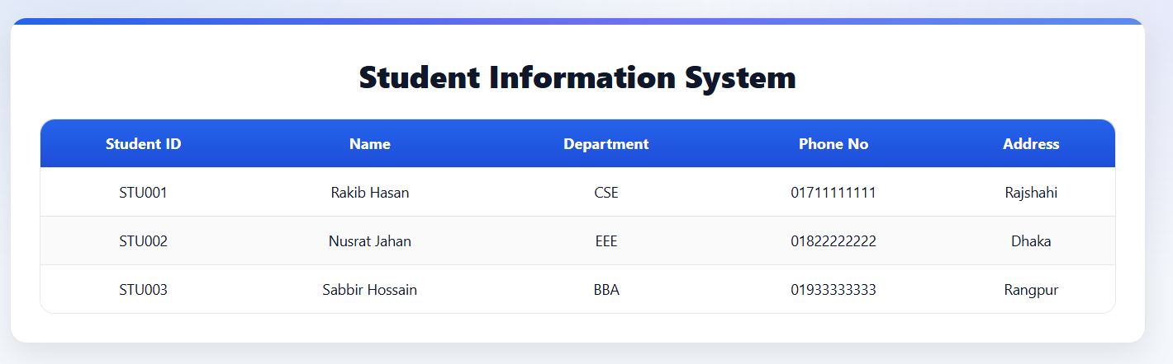
Now runserver again.

Add and entry to the database.
Student.objects.create(student_id='STU004', name='Manirujjaman', department='CSE', phone_no='01906446154', address='Rupgonj')
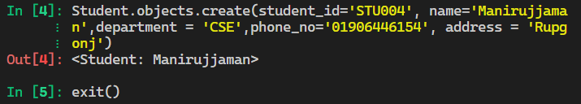

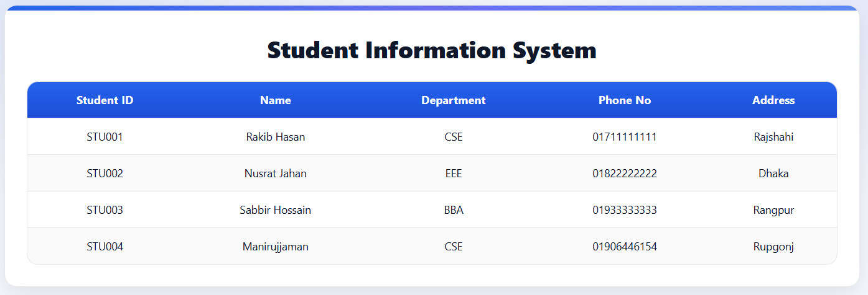

Now we’re going to make a new template called add_student.html — this one will help us insert data into the database and show it nicely on the student_list.html page.
First, let’s just render a demo HTML page (no pressure!). Then we’ll slowly connect it and pass the data to the database — step by step, like a chill coder! 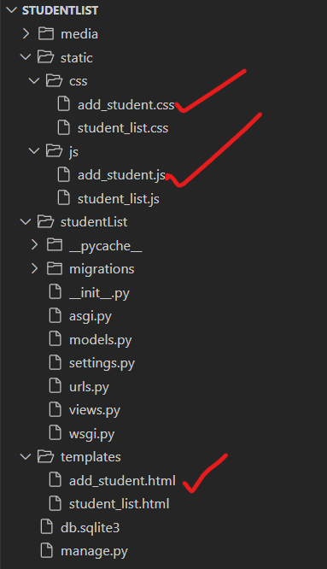

HTML (add_student.html)
<!DOCTYPE html>
<html lang="en">
<head>
<meta charset="UTF-8">
<meta name="viewport" content="width=device-width, initial-scale=1.0">
<title>Add Student</title>
{% load static %}
<link rel="stylesheet" href="{% static 'css/add_student.css' %}">
</head>
<body>
<div class="container">
<h1>Add Student Information</h1>

<!-- ✅ Form for adding student -->
<form method="POST" id="addStudentForm">
{% csrf_token %}
<div class="form-group">
<label for="student_id">Student ID:</label>
<input type="text" id="student_id" name="student_id" required>
</div>

<div class="form-group">
<label for="name">Full Name:</label>
<input type="text" id="name" name="name" required>
</div>

<div class="form-group">
<label for="department">Department:</label>
<input type="text" id="department" name="department" required>
</div>

<div class="form-group">
<label for="phone_no">Phone No:</label>
<input type="text" id="phone_no" name="phone_no" required>
</div>

<div class="form-group">
<label for="address">Address:</label>
<input type="text" id="address" name="address" required>
</div>

<button type="submit">Add Student</button>
</form>

<a href="{% url 'student_list' %}" class="back-link">← Back to Student List</a>
</div>

<script src="{% static 'js/add_student.js' %}"></script>
</body>
</html>

(add_student.css)
body {
font-family: Arial, sans-serif;
background-color: #f3f6fa;
display: flex;
justify-content: center;
align-items: center;
height: 100vh;
}

.container {
background-color: #fff;
padding: 25px;
border-radius: 12px;
box-shadow: 0 2px 10px rgba(0, 0, 0, 0.1);
width: 380px;
text-align: center;
}

h1 {
color: #333;
margin-bottom: 20px;
}

.form-group {
margin-bottom: 15px;
text-align: left;
}

label {
display: block;
margin-bottom: 5px;
font-weight: bold;
color: #555;
}

input {
width: 100%;
padding: 8px;
border: 1px solid #bbb;
border-radius: 6px;
outline: none;
}

input:focus {
border-color: #4CAF50;
}

button {
background-color: #4CAF50;
color: white;
border: none;
padding: 10px 15px;
border-radius: 8px;
cursor: pointer;
font-size: 16px;
}

button:hover {
background-color: #45a049;
}

.back-link {
display: inline-block;
margin-top: 15px;
color: #333;
text-decoration: none;
}

.back-link:hover {
text-decoration: underline;
}

.messages {
margin-bottom: 15px;
}

.message {
background-color: #e7f7e7;
color: #2e7d32;
border: 1px solid #b2d8b2;
border-radius: 5px;
padding: 10px;
}

Updated: js. (add_student.js)
document.getElementById('addStudentForm').addEventListener('submit', function(event) {
const confirmSubmit = confirm("Are you sure you want to add this student?");
if (!confirmSubmit) {
event.preventDefault();
}
});

Again update views.py as fellow:
from django.http import HttpResponse #for displaying simple text response to my browser
from django.shortcuts import render
from .models import Student

def homePage(request):
return HttpResponse("<h1>This a simple Home page </h1>")
def student_list(request):
students=Student.objects.all()
context={'students':students}
return render(request, 'student_list.html', context)

def add_student(request):
return render(request, 'add_student.html')
Again update urls.py as fellow:
from django.contrib import admin
from django.urls import path
from . import views

urlpatterns = [
path('admin/', admin.site.urls),
path('', views.homePage, name='home'), # Map the root URL to the homePage view
path('student-list/', views.student_list, name='student_list'),
path('add-student/', views.add_student, name='add_student'),
]
You will get output of page as like follows:
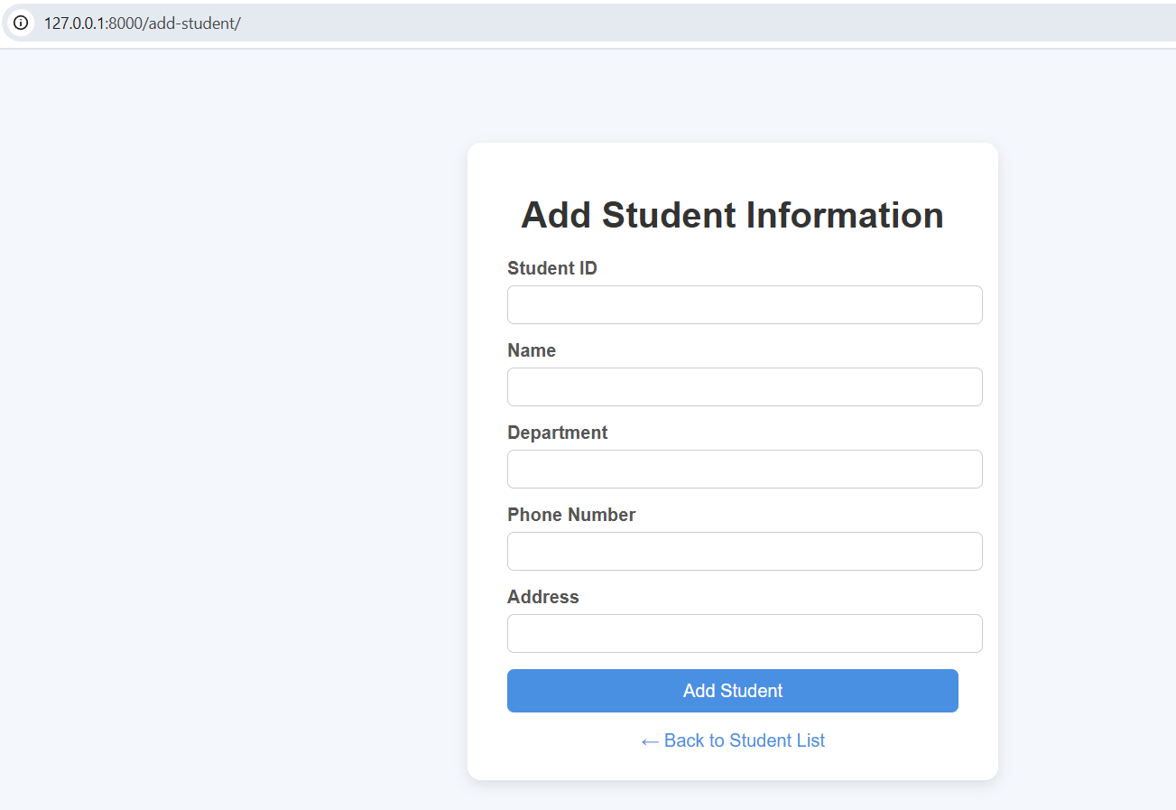
Now main task - passing data from the form to Student database.
Updated views.py.
from django.http import HttpResponse #for displaying simple text response to my browser
from django.shortcuts import render,redirect
from .models import Student
from django.contrib import messages
from django.db import IntegrityError

def homePage(request):
return HttpResponse("<h1>This a simple Home page </h1>")
def student_list(request):
students=Student.objects.all()
context={'students':students}
return render(request, 'student_list.html', context)

def add_student(request):
if request.method == 'POST':
student_id = request.POST.get('student_id')
name = request.POST.get('name')
department = request.POST.get('department')
phone_no = request.POST.get('phone_no')
address = request.POST.get('address')

try:
Student.objects.create(
student_id=student_id,
name=name,
department=department,
phone_no=phone_no,
address=address
)
#messages.success(request, '✅ Student added successfully!')
return redirect('student_list')

except IntegrityError:
messages.error(request, f'⚠️ Student ID "{student_id}" already exists. Please use a unique ID.')
return redirect('add_student')

return render(request, 'add_student.html')

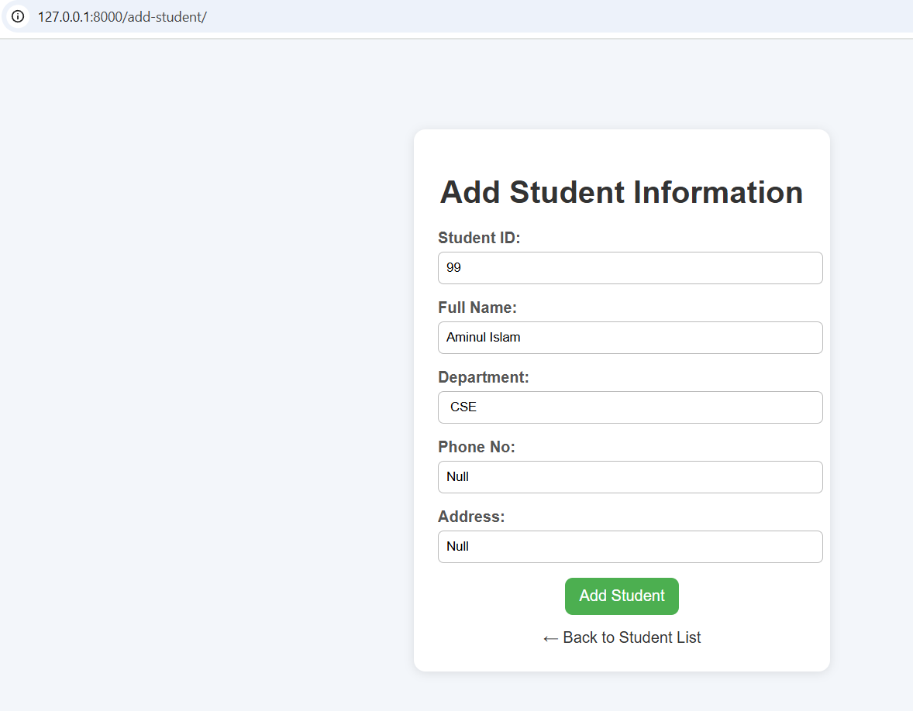
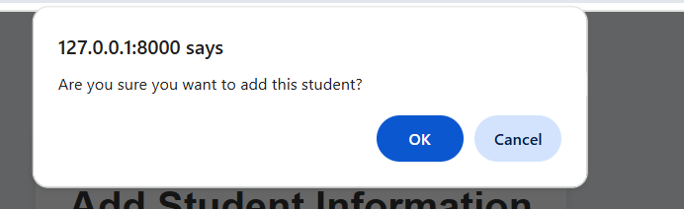
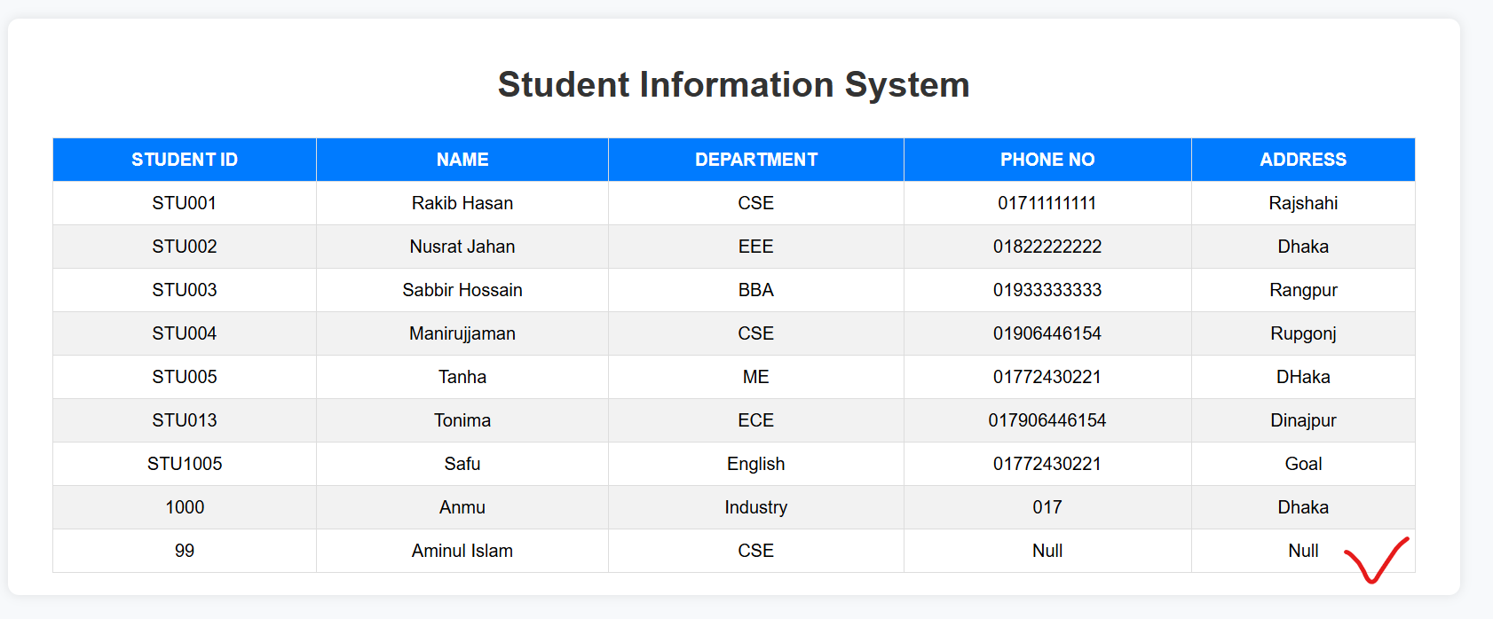

That’s All for Today

